POWER BI REAL-TIME DASHBOARD PROJECTS WITH DATASET LINKS & ANALYSIS

1.Hospital beds management dashboard
Dataset Name: Hospital beds management
Link: https://www.kaggle.com/datasets/jaderz/hospital-beds-management
Fields: Title Beds Availability, Patient Admitted, Staff Availability, Service, Patients Statisfication.
Problem Statement: Hospitals face difficulty managing bed availability, patient admissions, staff allocation, and service workload. Due to limited beds, some patients are refused even when the hospital appears operational. The hospital needs a dashboard to:
- Track available vs. occupied beds
- Analyze patient admissions and refusals
- Monitor staff availability
- Improve service efficiency and patient satisfaction
- Forecast required beds/staff based on weekly trends
This Power BI project will help the hospital make data-driven decisions, reduce refusals, and improve patient satisfaction.
Solution Using Power BI: ✔ Combine Patients, Service Weekly, Staff, and Staff Schedule tables
✔ Create relationships between tables
✔ Build KPIs like:
- Total Beds
- Bed Occupancy %
- Patient Admission Rate
- Staff Availability %
- Patient Satisfaction Score
✔ Provide interactive visuals such as:
- Trend charts
- Bed availability gauge
- Refused vs admitted comparison
- Service performance matrix
✔ Enable hospital management to quickly adjust staffing and improve patient flow.
Dashboard Features: A. Patient Management Section
Uses: patient_id, name, age, arrival_date, departure_date, service, satisfaction
✔ Patient count (admitted, discharged)
✔ Average patient satisfaction
✔ Length of stay by service
✔ Patient distribution by service (chart)
✔ List of current inpatients

B. Bed Management Section (Weekly Service Data)
Uses: week, month, service, available_beds, patients_request, patients_admitted, patients_refused, patients_satisfaction, staff_morale, event
✔ Available beds vs occupied beds
✔ Admission vs refusal comparison
✔ Bed occupancy percentage
✔ Weekly and monthly trend of patient requests
✔ Service-wise satisfaction and morale indicators
✔ Events affecting service performance (e.g., maintenance, festivals)

C. Staff Management Section
Uses: staff_id, staff_name, role, service
✔ Total staff by role & service
✔ Staff-to-patient ratio
✔ Department-wise manpower availability

D. Staff Attendance / Schedule Section
Uses: week, staff_id, staff_name, role, service, present
✔ Staff attendance %
✔ Week-by-week attendance trend
✔ Staff shortage alerts
✔ Service-wise present vs required staff

E. KPI Section
✔ Total Beds
✔ Bed Occupancy %
✔ Admission Rate
✔ Refusal Rate
✔ Average Patient Satisfaction
✔ Staff Morale Score
Outputs:
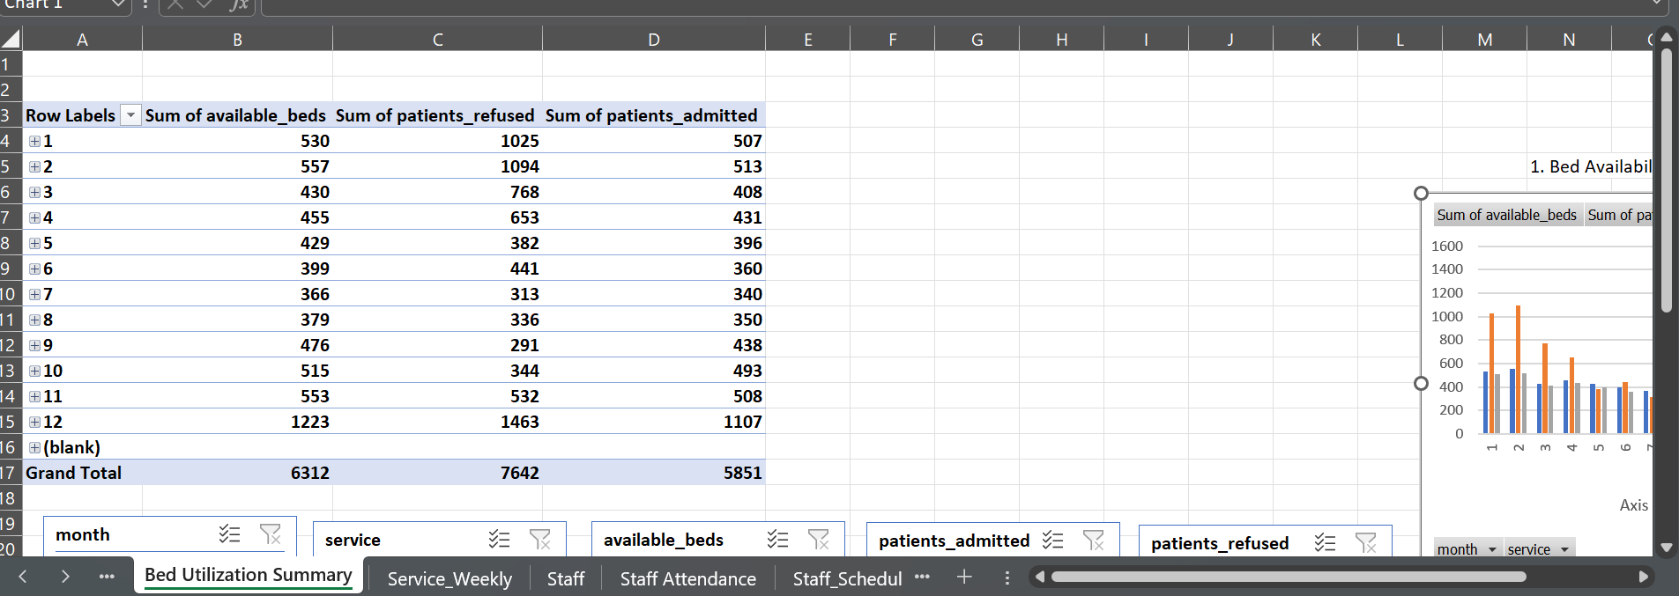
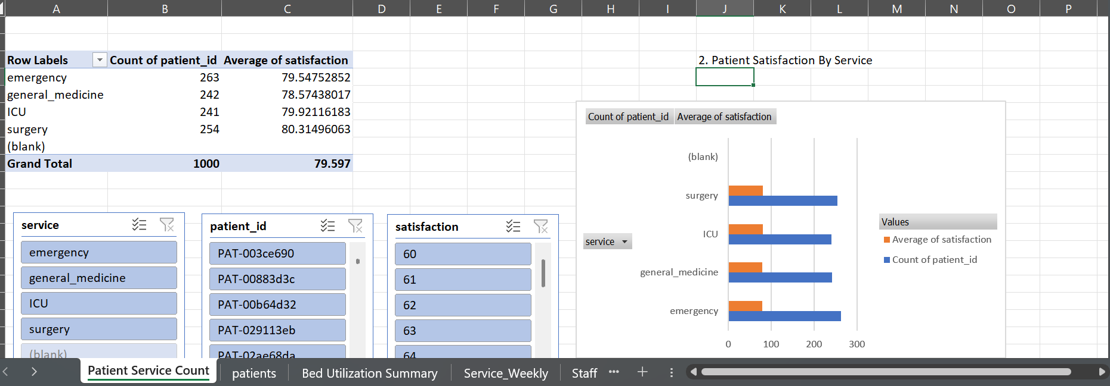
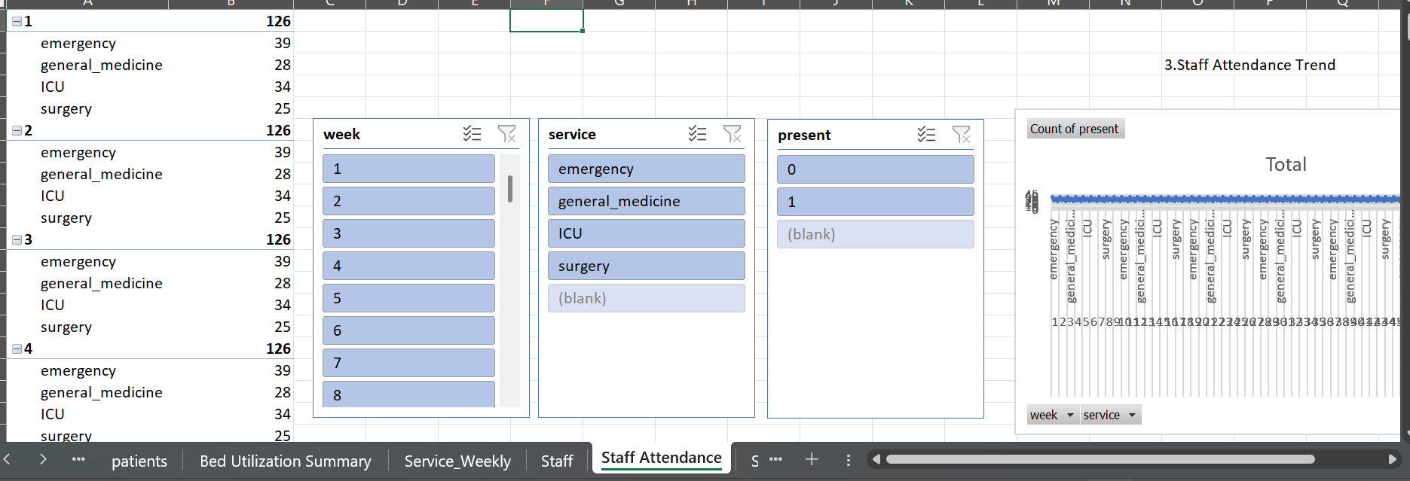
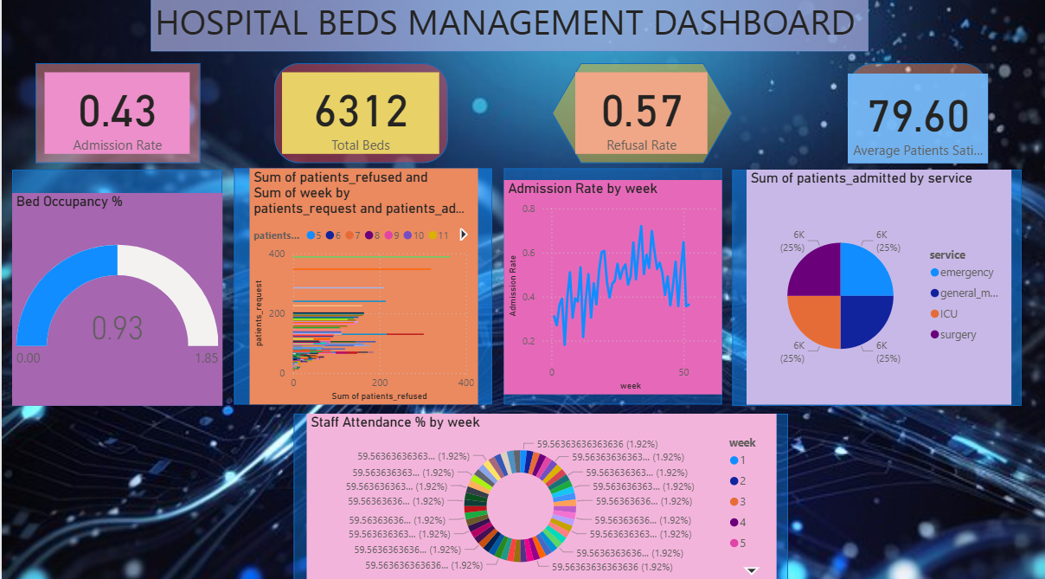
Outcomes: A. Improved Bed Utilization
➡ Identifies underused and overused services
➡ Optimizes bed allocation across departments

B. Reduced Patient Refusals
➡ Shows when requests > available beds
➡ Helps plan extra beds or shift patients

C. Better Patient Experience
➡ Tracks satisfaction trends
➡ Helps improve low-performing services

D. Strong Staff Planning
➡ Detects staff shortages
➡ Improves scheduling using attendance patterns

E. Early Identification of Operational Issues
➡ Events + morale + refusals show operational bottlenecks
➡ Management can act before crises increase

F. Faster Data-Driven Decisions
➡ Real-time KPIs
➡ Easy comparison across weeks, months, and services

